**Keypad**

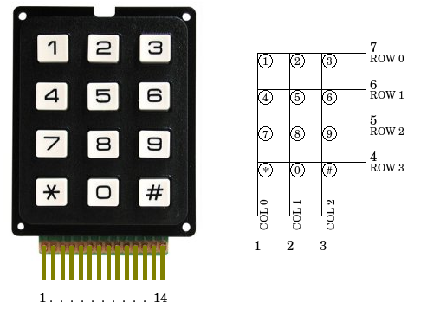

1. Get acquainted with the pin numbers of the Keypad.

2. Download Arduino’s Keypad Library.

3. Learn/know functions used in Keypad Library: <http://playground.arduino.cc/code/Keypad>

4. Basic program: <http://playground.arduino.cc/Main/KeypadTutorial>